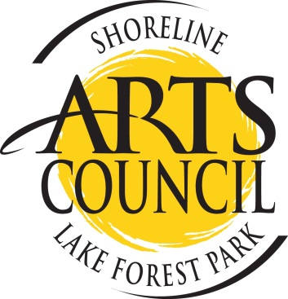
MiniGrants – APPLICATION 2020
For Teens and Culturally Diverse Populations
Contact Person: __________________________________________________________
Address:___________________________________________________________________________
Phone:___________________________ Email:____________________________________________
Project Name: ______________________________________________________________
Which group? (check one or both):  Teens  Culturally Diverse Population
The Plan – what are you going to do?
_________________________________________________________________________________
_________________________________________________________________________________
_________________________________________________________________________________
_________________________________________________________________________________
How many people will participate:
When? (start date and finish date (by August 31, 2020):
BUDGET
What do you need to pay for: teacher, supplies, room, etc. Grant awards may be up to $300.
Item | Cost
Total | $

I certify the above is true, and I will submit a project summary (with photos) if I am awarded the grant.
Signature______________________________________________________Date_______________________
Send completed application to: artsed@shorelinearts.net or deliver to the Shoreline-Lake Forest Park Arts Council Office, 18560 1st Ave NE, Shoreline, WA 98155.

